I just write a brief description for you. I am trying to model turbulent flow in a pipe and annulus and find the pressure and velocity distributions in other way.
The configuration of the problem is shown in Figure 1. The flow is going to the pipe and is coming back from the annulus. The pipe has porous wall so that the flow in the pipe can permeate to the annulus and come back.

porous wall
Permeate flow

Outlet from annulus
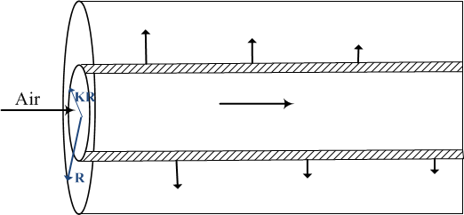
Closed end
Length of pipe: 10 m

Figure 1

To model it in Comsol, I used “2D axisymmetric” study, and defined 3 domain, pipe, porous wall and annulus. I added different physics for each of these domains.
1- “Turbulent flow (k-ε)” for the flow through the pipe
2- “Darcy’s law” for flow through the porous wall.
3- “Turbulent flow (k-ε)” for the flow through the annulus
The domains, geometry, physics and defined boundary conditions are shown in figure 2,3
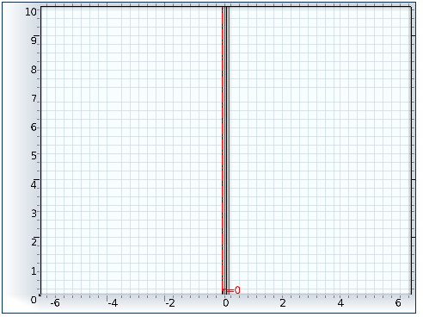
Figure 2

No flow
Wall (wall function)
Wall (wall function)

Domain 1  Pipe  Axisymmetric  Turbulent flow (k-ε)  0.1m | Domain2  Porous wall  Darcy’s law  0.05 m | Domain 3  Annulus  Turbulent flow (k-ε)  Wall (wall function)  Length of the pipe (z=10m)  0.1m
Outlet (no viscose stress, pressure=P0)

No flow
Inlet (inflow velocity=V0)

Figure 3
Now, there are two boundaries which are shared between the domains. Actually, “outlet” boundary condition in each of these physics is “inlet” boundary condition for the other physics. For example, “outlet” of the pipe is “inlet of the porous media”, and vice versa. I put one of them in red and the other one in green in Figure2.
I tried to couple these three physics together by using the bellow boundary conditions.
- For the red boundary:
In study 1 which is “Turbulent flow (k-ε) in pipe”, I defined this boundary as
“ wall (slip wall)”. And in study 2 “ darcy’s law”, I defined it as”inlet (inflow velocity=u*nr+w*nz)”

- For the green boundary:
In study3 which is “ Turbulent flow (k-ε) in annulus”, I defined this boundary as “ wall (slip wall)”. And in study 2 “ darcy’s law”, I defined it as”outlet (inflow velocity=u*nr+w*nz)”
Where “u” and ” w” are the velocity field ( dependent variables) in these three physics.
I also defined same parameters in “dependent variables” section for all these three physics. For example I defined “ P” as pressure in domain1,2,3. And I defined “u,v,w” as velocity field in domains 1,2,3.
I put the results of “ velocity profile in r-direction at z=5m which is the middle of the pipe”. It seems in the “results” section they are not still coupled. you can see that the velocity distribution in each domain are not consistent with each other. For example, at r=0.1m which is the outlet pf pipe and inlet of porous wall. The velocity at r=0.1m in pipe is 2.6006 but in porous media is 1.45.
How can I fix the problemand define the model in Comsol so that all these 3 physics become coupled? Do I need to do anything else to couple these 3 physics together?
I really appreciate if you would help me with that

