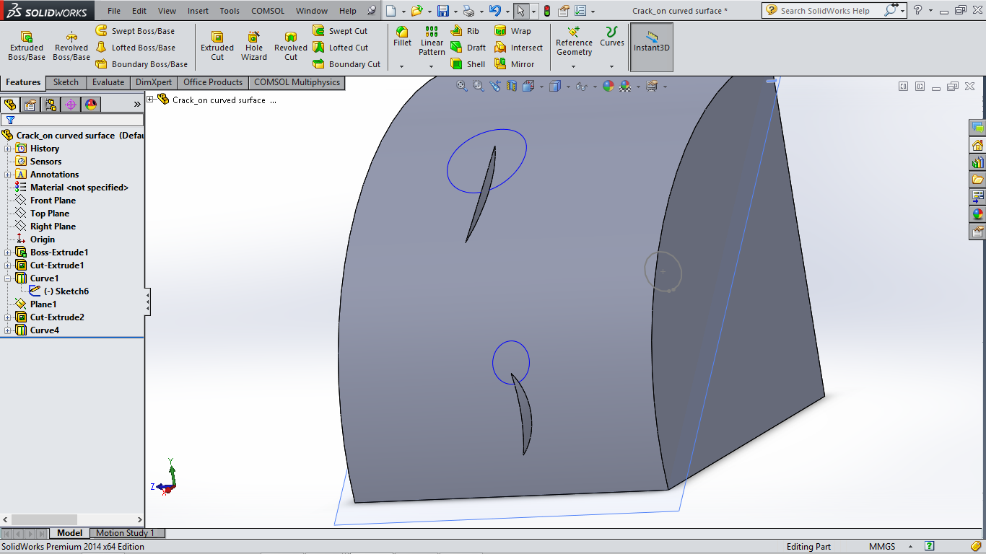

Circular line/edge selection around crack tip.

Note that the line selection can be of any shape(eg square) as long as it forms a closed contour around the crack tip.