20.1.2016 HorizontalFin
Date
Mar 4, 2016 2:33:27 PM
Dear Jeff
I am enclosing the complete report for you which I had solved.
Also I am uploading the Paper which I am actually trying to Validate by COMSOL(Page 43, 45).
The Visualization is not as per the Paper enclosed .
Basically I am trying to separate the fin and cavity for the results, but I am solving NS equations for both fluid and the fin.

Thanking you
Contents
1. Global Definitions
1.1. Parameters 1
2. Component 1 (comp1)
2.1. Definitions
2.2. Geometry 1
2.3. Heat Transfer in Fluids (ht)
2.4. Laminar Flow (spf)
2.5. Heat Transfer in Solids 2 (ht2)
2.6. Mesh 1
3. Study 1
3.1. Parametric Sweep
3.2. Stationary
4. Results
4.1. Data Sets
4.2. Plot Groups

- Global Definitions
  - Parameters 1
Parameters
Name | Expression | Description
Tc | 0 | Low Temperature
Th | 1 | High Temperature
Pr | 0.71 | Prandtl Number
p0 | 0 | Reference Pressure
Ra | 0 | Rayleigh Number

- Component 1 (comp1)
  - Definitions
    - Coordinate Systems
      - Boundary System 1
Coordinate system type | Boundary system
Identifier | sys1

  - Geometry 1
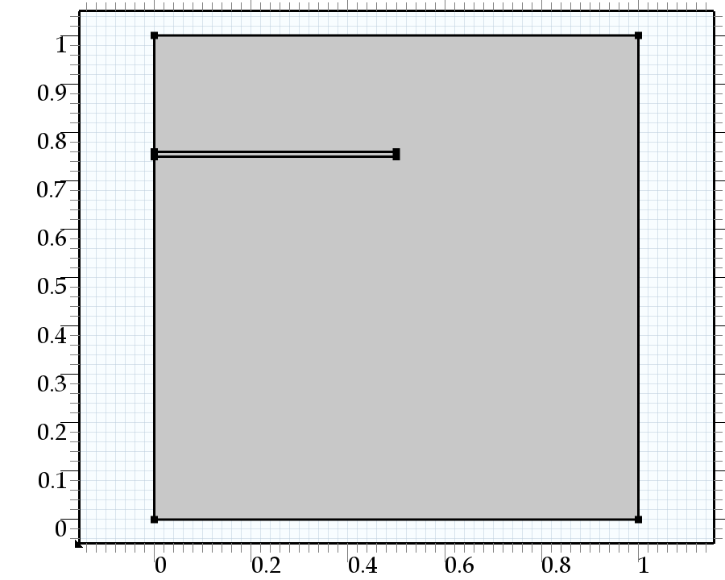
Geometry 1
Units
Length unit | m
Angular unit | deg

  - Heat Transfer in Fluids (ht)
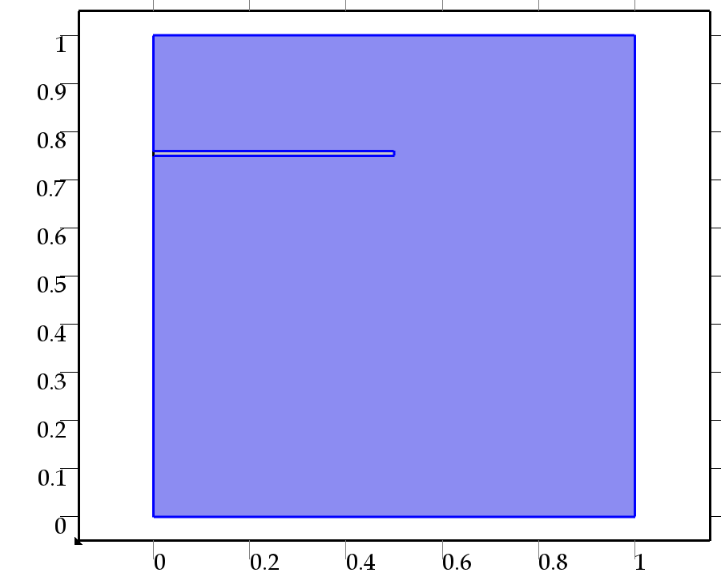
Heat Transfer in Fluids
Features
Heat Transfer in Fluids 1: pressure=p0(as per Parameter), k=1, cp=Pr, Y=1, Density=1(all made dimensionless)
Thermal Insulation 1: Top wall and Bottom wall (as per paper)
Initial Values 1: Tc
Temperature 1: Wall 1 maintained at higher Temp Th
Temperature 2: Wall 9 maintained at lower Temp Tc
Heat Flux 1: h=1(heat transfer coefficient), external temp=Th(General inward flux)
Heat Flux 2, h=0 Tc

  - Laminar Flow (spf)
Laminar Flow
Features
Fluid Properties 1:
Wall 1: Left wall is maintained at Th wheras Right wall is maintained at TC
Initial Values 1: Initial Temperatute=Tc
Volume Force 1: (Ra/Pr) *(T-Tc) considering The Boussinesq approximation
Pressure Point Constraint 1: Upper right point(as per geometry pt:4)

  - Heat Transfer in Solids 2 (ht2)
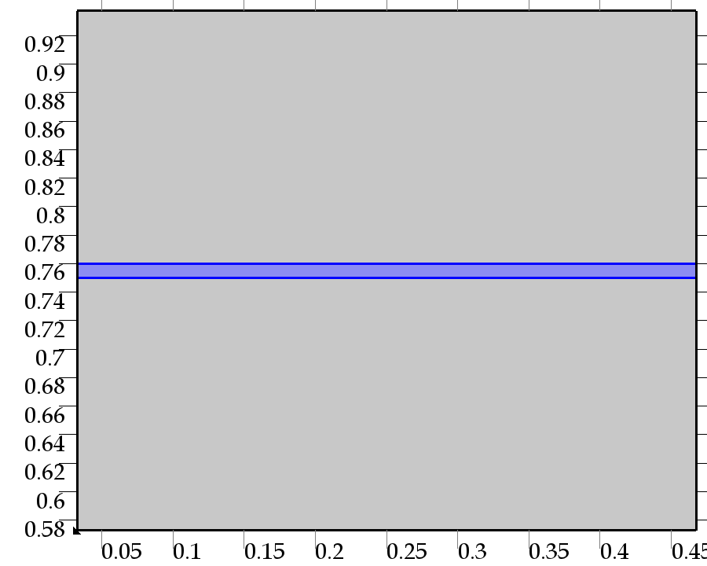
Heat Transfer in Solids 2
Features
Heat Transfer in Solids 1
Thermal Insulation 1: All the walls of the Fin as per geometry defined
Initial Values 1: Maintained at cavity’s Temperature Tc

  - Mesh 1
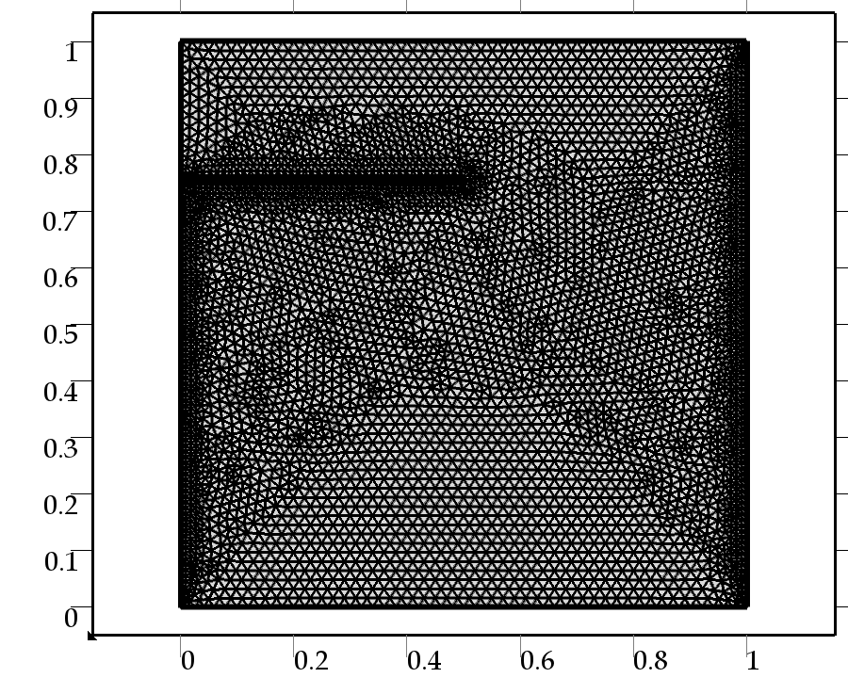
Mesh 1
- Study 1
  - Parametric Sweep
Parameter name: Ra
Parameters: 1e5, 1e6, 1e7
Stationary solver 1( Initial value based)
Stationary solver 1: Fully coupled
Method and Termination:
Non linear method: Automatic highly non linear
Initial damping factor: 1
Minimum Damping factor: 1E-4
Maximum No of Iterations: 25
Tolerance factor:1e-3
  - Stationary
Study settings
Property | Value
Include geometric nonlinearity | Off

Mesh selection
Geometry | Mesh
Geometry 1 (geom1) | mesh1

Physics selection
Physics | Discretization
Heat Transfer in Fluids (ht) | physics
Laminar Flow (spf) | physics
Heat Transfer in Solids 2 (ht2) | physics

- Results
  - Data Sets
    - Solution 1
Solution
Name | Value
Solution | Solver 1
Component | Save Point Geometry 1

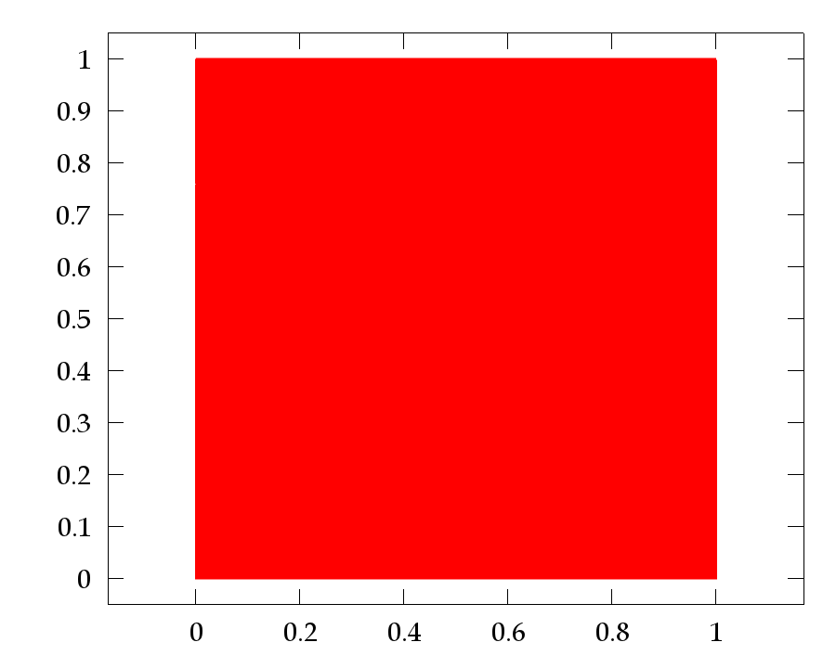
Data set: Solution 1
  - Plot Groups
    - Temperature (ht)
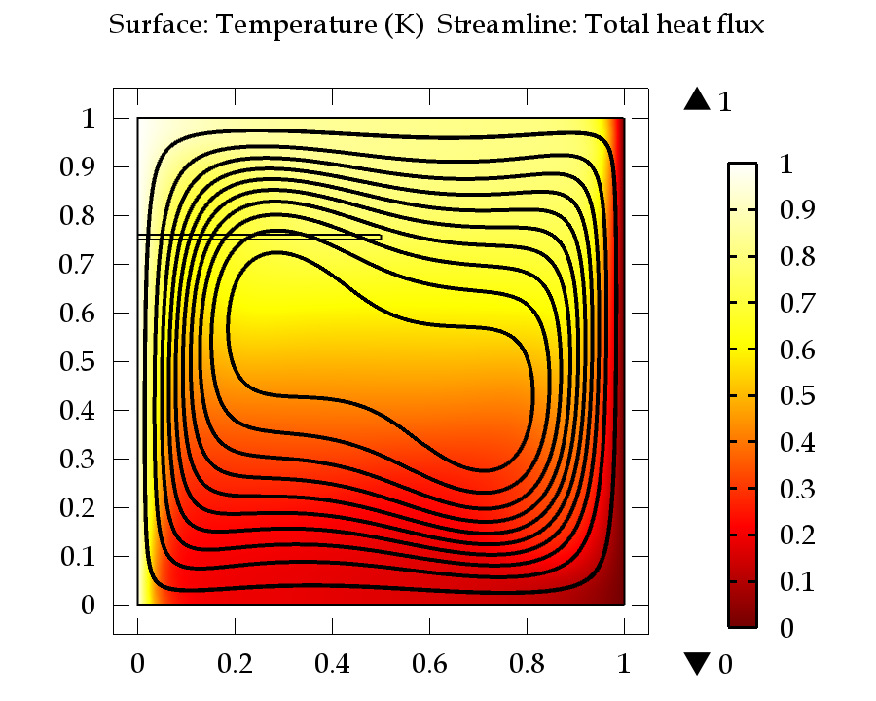
Surface: Temperature (K) Streamline: Total heat flux
    - Isothermal Contours (ht)
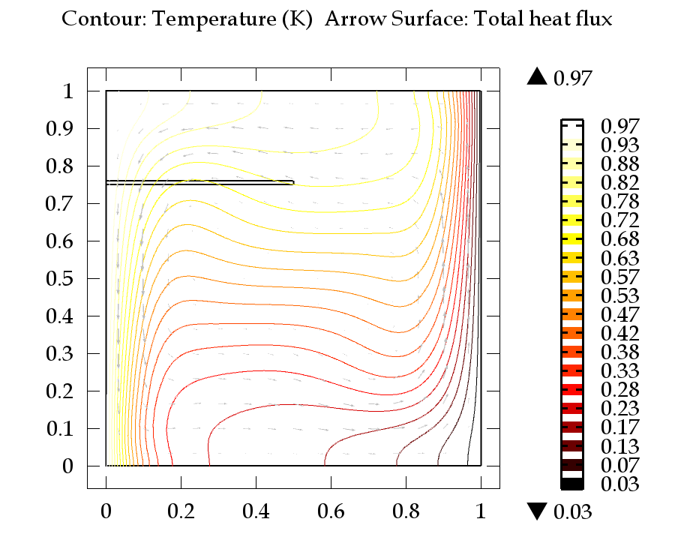
Contour: Temperature (K) Arrow Surface: Total heat flux
    - Velocity (spf)
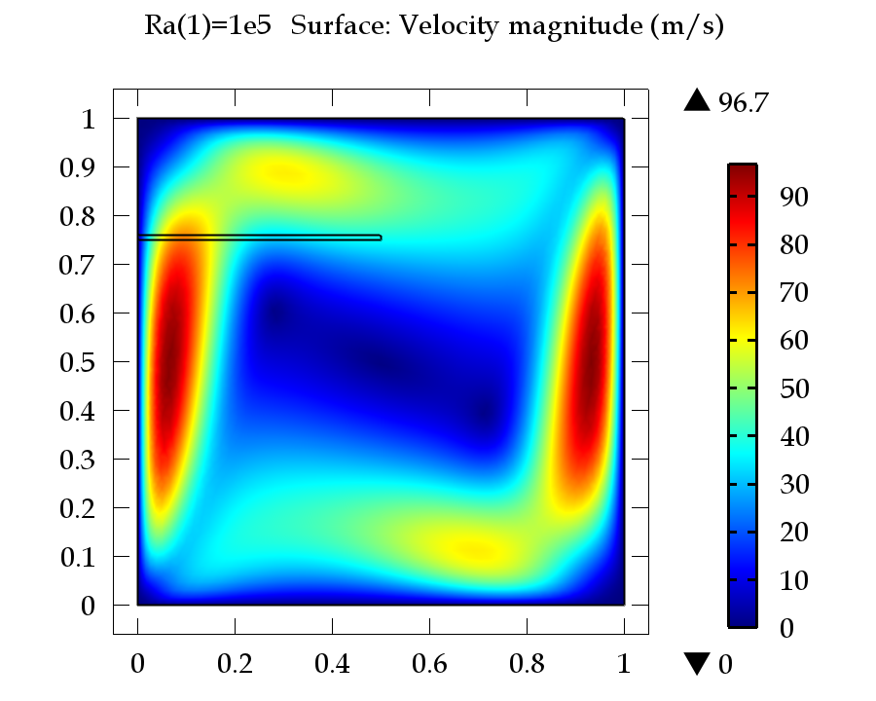
Ra(1)=1e5 Surface: Velocity magnitude (m/s)
    - Pressure (spf)
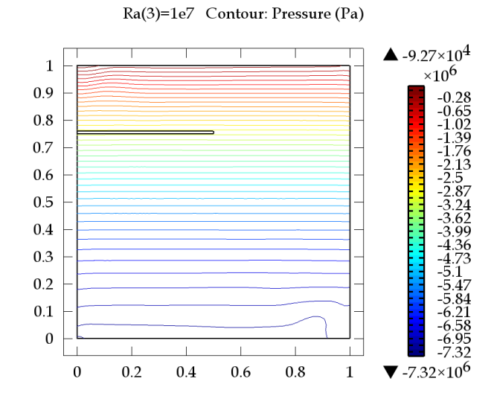
Ra(3)=1e7 Contour: Pressure (Pa)

