I am looking for solution of Laplace equation
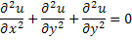
Inlet
Outlet 2

Outlet 3
Tank

