Problem is not related to the heat transfer,
Problem is related to the burning of mustard husk and dunk cake present in the different layer
There are 8 different layer placed one above the other,
Load (Earthen ware ) is present on the layer 4
Fire will start from the center of the layer 5 & 6

Combustion will take place in the layer 5 & 6, once the fire will reach the periphery of the layer 5 and 6 ,it will propagate to the layer 1 ,2 & 3 Through the mustard husk present in the periphery
Layer 7 and 8 are used only for insulation purpose
Main aim of the work is to find the temperature profile of layer 4 (layer which contain earthen ware)
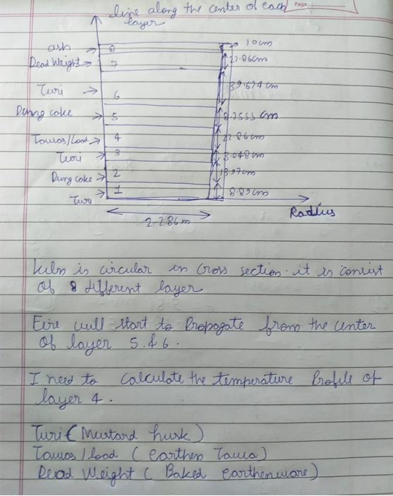

Actual image of the kiln
