The below images represent what we have been able to create in COMSOL. These train of pulses have a duration of ~ 40ms and frequency of 1ms. Our aim is to generate a train of pulses with pulse duration = 2-4 ms and frequency of 1s.

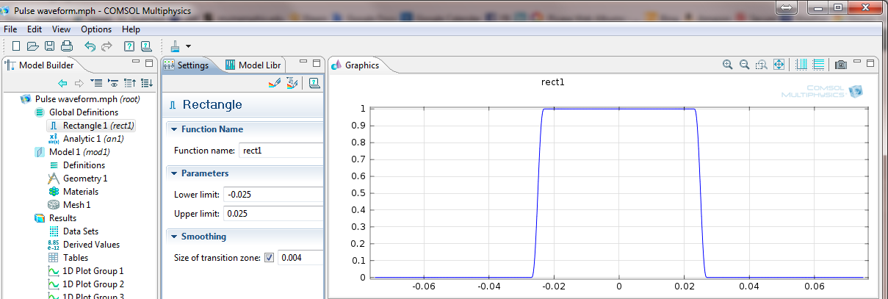

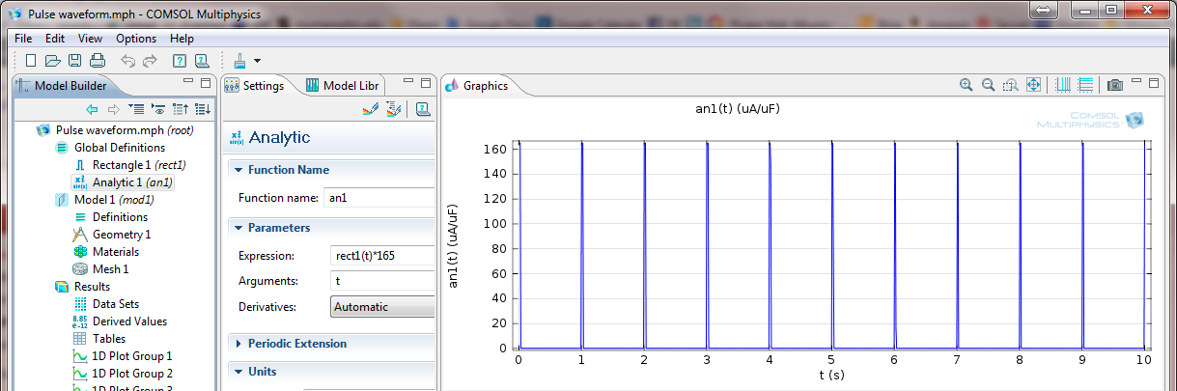

When we attempt to generate a train of pulses with pulse duration = 2-4 ms and frequency of 1s the images below demonstrate the results. We are unable to understand why we cant get a pulse every second with the same amplitude and frequency instead of the attenuated response.

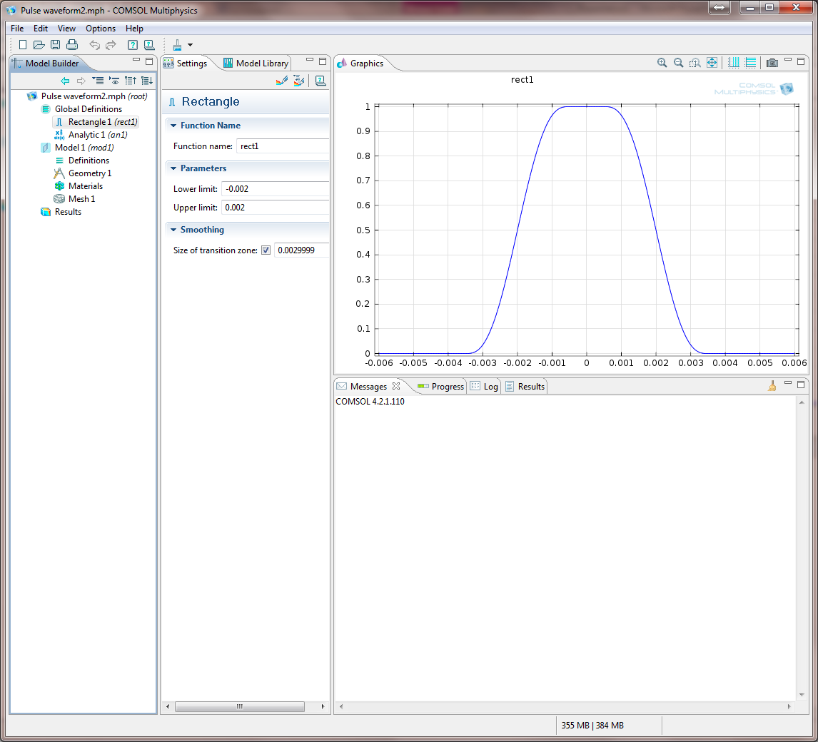

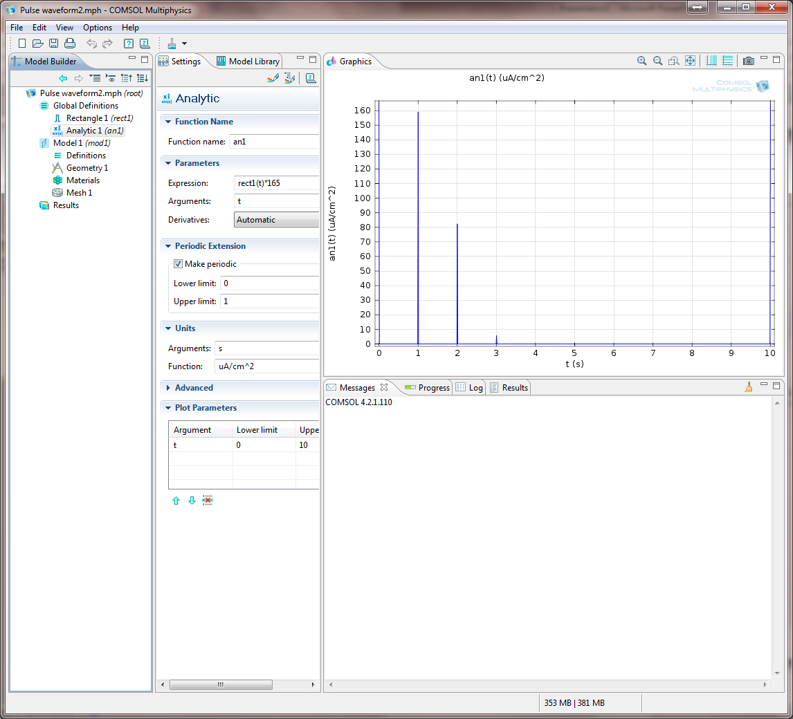
Now we import data from a txt file into an interpolation function as shown in the top image and use an analytic function to make the data periodic (though we have the entire data in a file it is too huge to be completely imported into an interpolation function). The bottom image shows how in our attempt to repeat the waveform every 1s for 10s the peak is attenuated to 12 from ~165.
